**BOX OFFICE MANAGEMENT**

**MINI PROJECT REPORT**

Department of Master of Computer Applications

**By**

**SRIDEVI M**

**C19102PCA6052**

Under the Guidance of

**DR.R. VELMURUGAN**

**ABSTRACT**

**Movie Cruiser–Box Office Management** is a web-based application developed using Jsp, Java, servlet, CSS, JavaScript, and MySQL to register data. The proposed project for the Movie Cruiser – Box Office Management is developed to provide the Movie details to the users. This is beneficial to both the admins and users. Using the online web application, the admin can do managing activities such as add new Movie items, edit, and delete the statistics and update or modify the existing details. It helps the user to track the movie details.

This Box Office Management web-based application can be used by the entertainment companies that want to start online movie streaming service. initially the entertainment companies want the customers to view the list of movies available and allow the customers to add them to their favorite wish list.

**2. SYSTEM REQUIREMENTS**

* 1. **Hardware Requirements**

|  |  |
| --- | --- |
| Processor | Intel Dual Processor 2.6 GHz |
| RAM | 4 GB RAM |
| Hard Disk | 500 GB |

* 1. **Software Requirements**

|  |  |
| --- | --- |
| Operating System | Windows 10 |
| IDE | Eclipse |
| Data Base | SQL Server |
| Front End | HTML, CSS, JSP, JS |
| Back End | JAVA, Servlet, JDBC |

1. **PROJECT DESCRIPTION**

**2.1 Description**

The website is fully focused on viewing the movie box office statistics up to date and enabling the user to add the items to favorite label to get easy handling. So, we have developed a website by providing item details and user-friendly platform for users

Website Admins to add / delete and update the existing movie items details in the application

This project describes Movie Cruiser – Box office collection management facilitates user to avail the movie details instantly and accurately. This System will provide facility for user to check the statistics anytime from anywhere.

This System allows the user to add their movie to wish list.

Admin can perform backend operations – Add, Delete, update existing movies to the website which will stores in the Database

* 1. **Modules**

This Project contains five modules, they are

1. Customer Registration
2. Movie List
3. Add to Favorite
4. Admin Edit / Add
5. Customer Remove Favorite
   * 1. **Customer Registration**

In this Customer module the customer register their details into the database. Once the customer registered their details the customer can access the details from and choose their favorite Movie from the movie list.

* + 1. **Movie List**

In this module the customer has the access the view the movie list with the box office details of the movie and the option to add the move to their favorite list .

**2.1.3 Add to Favorite**

In this Movie List module, the customer can add the favorite movie that the customer wish to see it in one click. The customer can see the favorite movies in the favorite’s menu.

**2.1.4Admin Edit / Add**

In this Admin Edit Add Module, Admin can add the new movie to the list and the access to edit the existing movie details.

**2.1.5 Customer Remove Favorite**

In this Remove Favorite module customer has the access to remove the selected favorites from their favorite list.

1. **DATA FLOW DIAGRAMS**
   1. **Use Case Diagram**

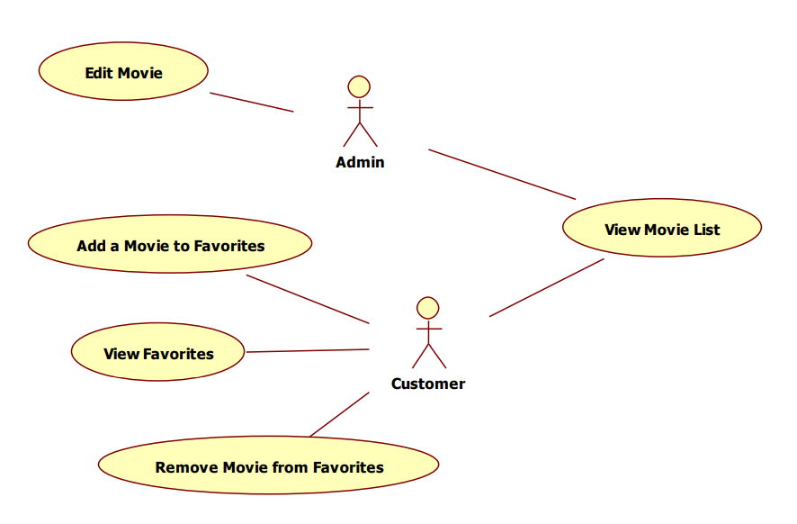

* 1. **Data Flow Diagram**

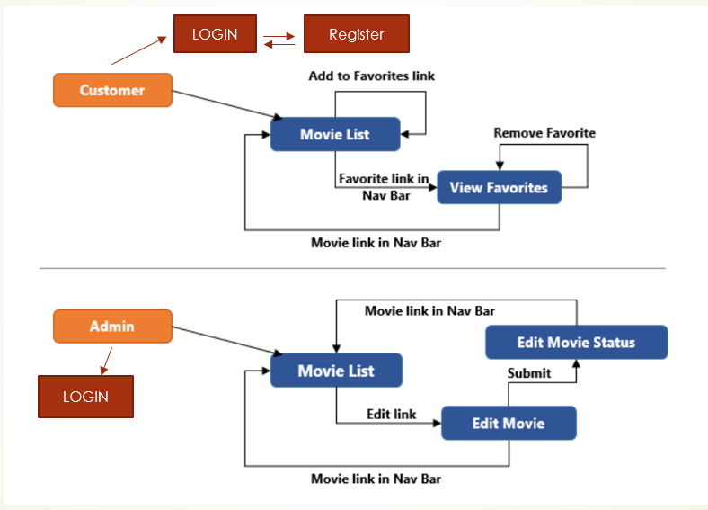

1. **TABLE DESIGN**
   1. User Table

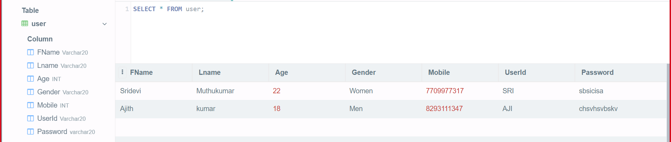

* 1. Item List

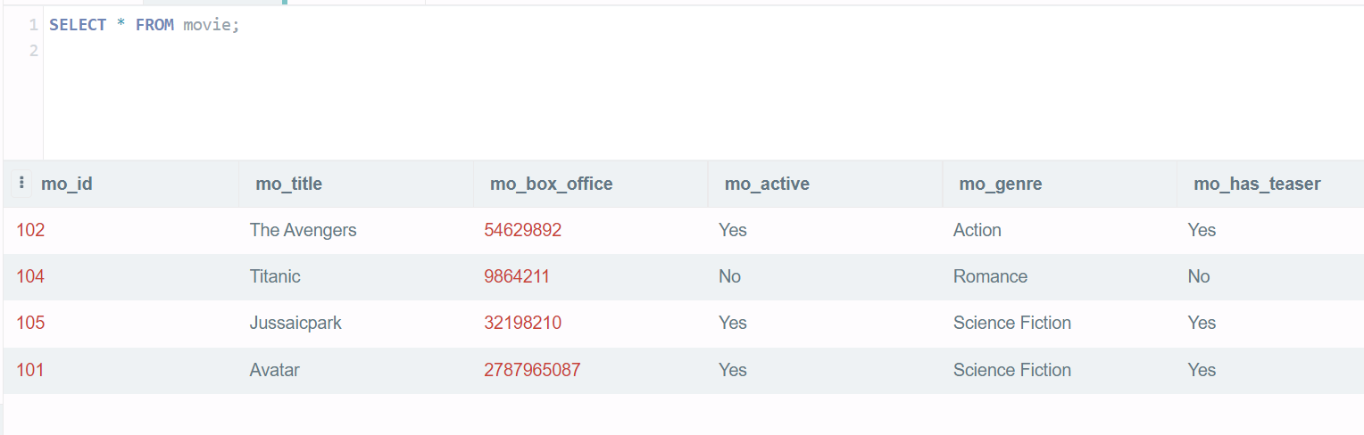

* 1. Admin Table

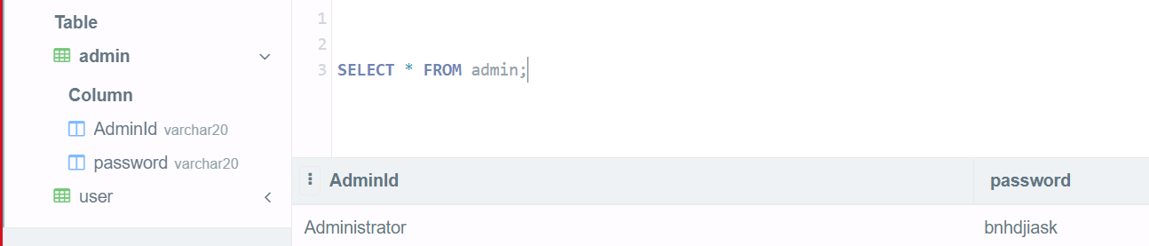

* 1. Favorite List Table

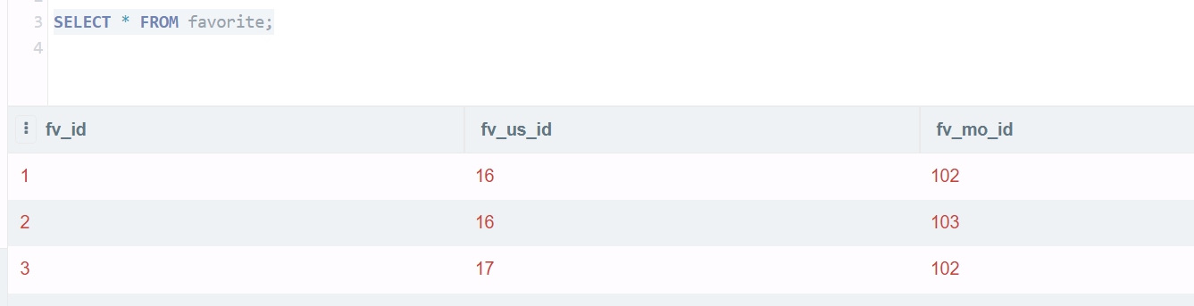

1. **FORMS AND REPORTS**
   1. Login Page - User

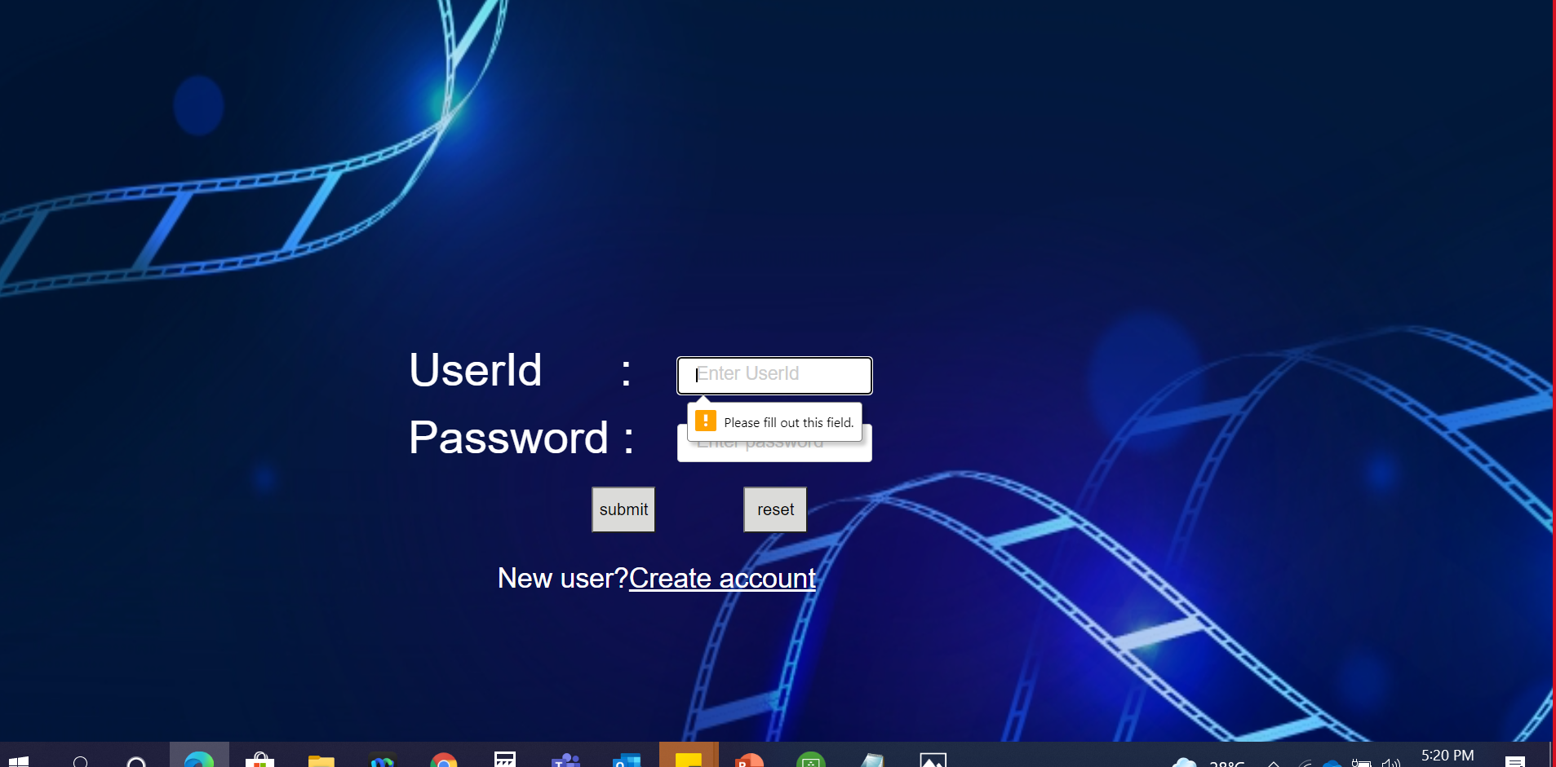

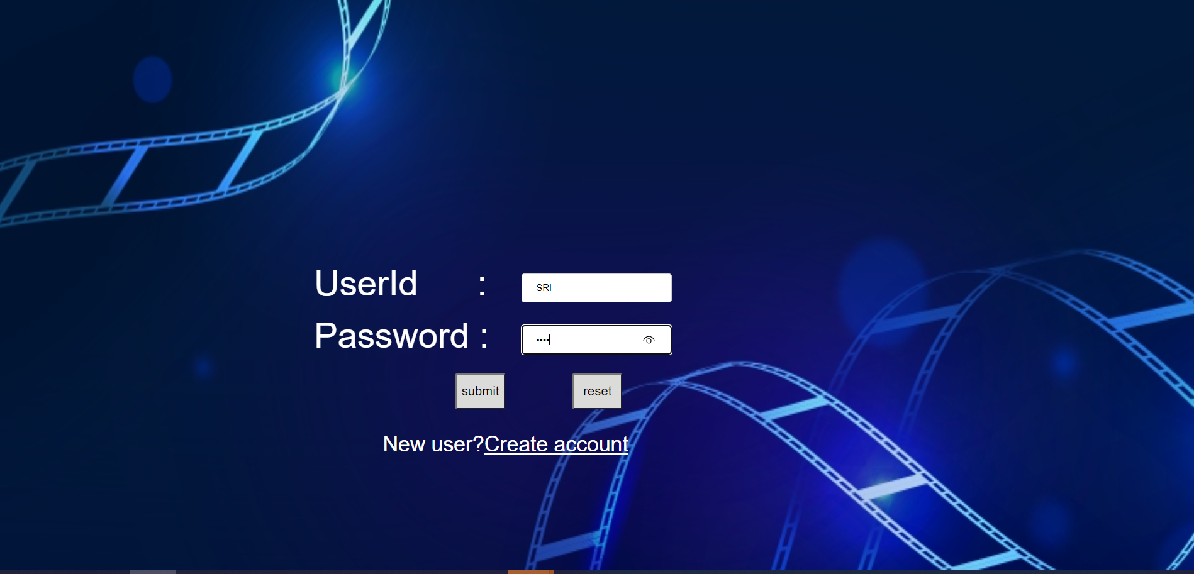

* 1. Registration Page

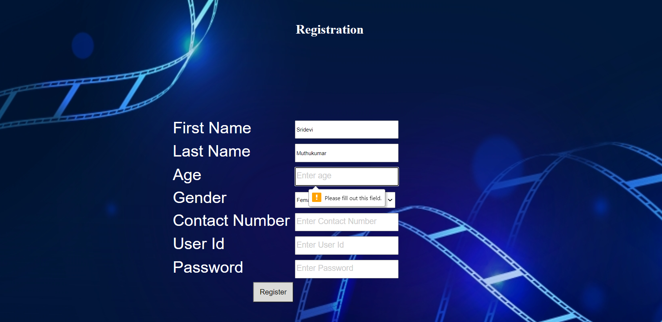

* 1. : Customer – Home Page

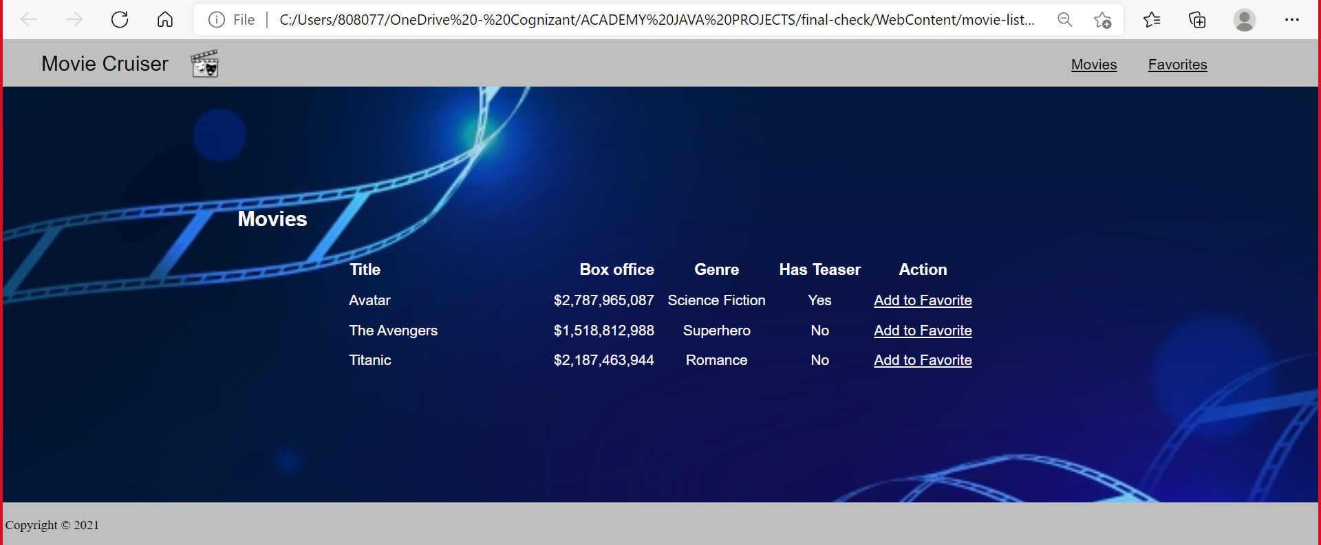

* 1. : Customer – Favorite addition information

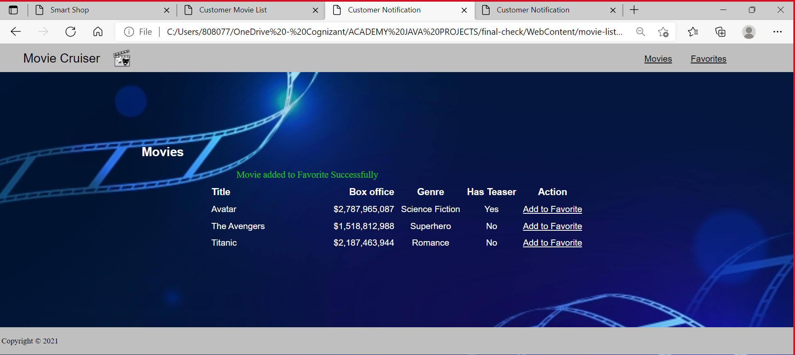

* 1. Customer Favorite page

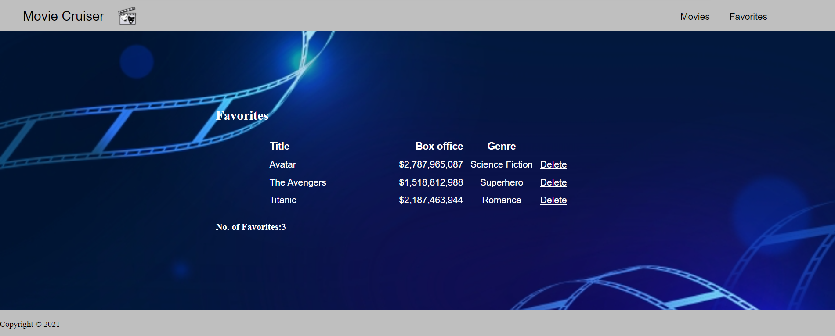

5.7 Customer Favorite page – Delete popup

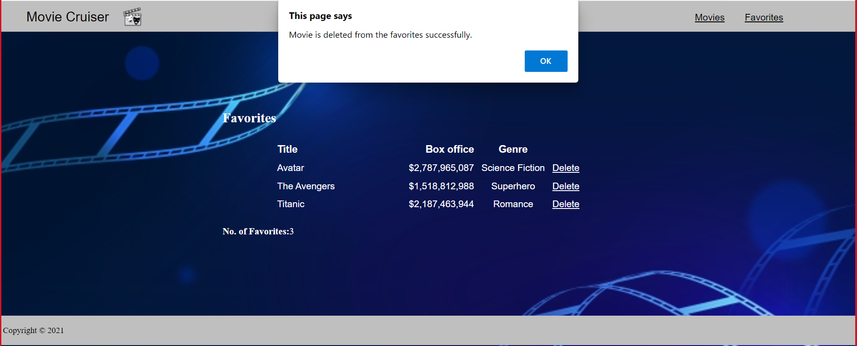

5.8 Customer Favorite page – Delete notification msg

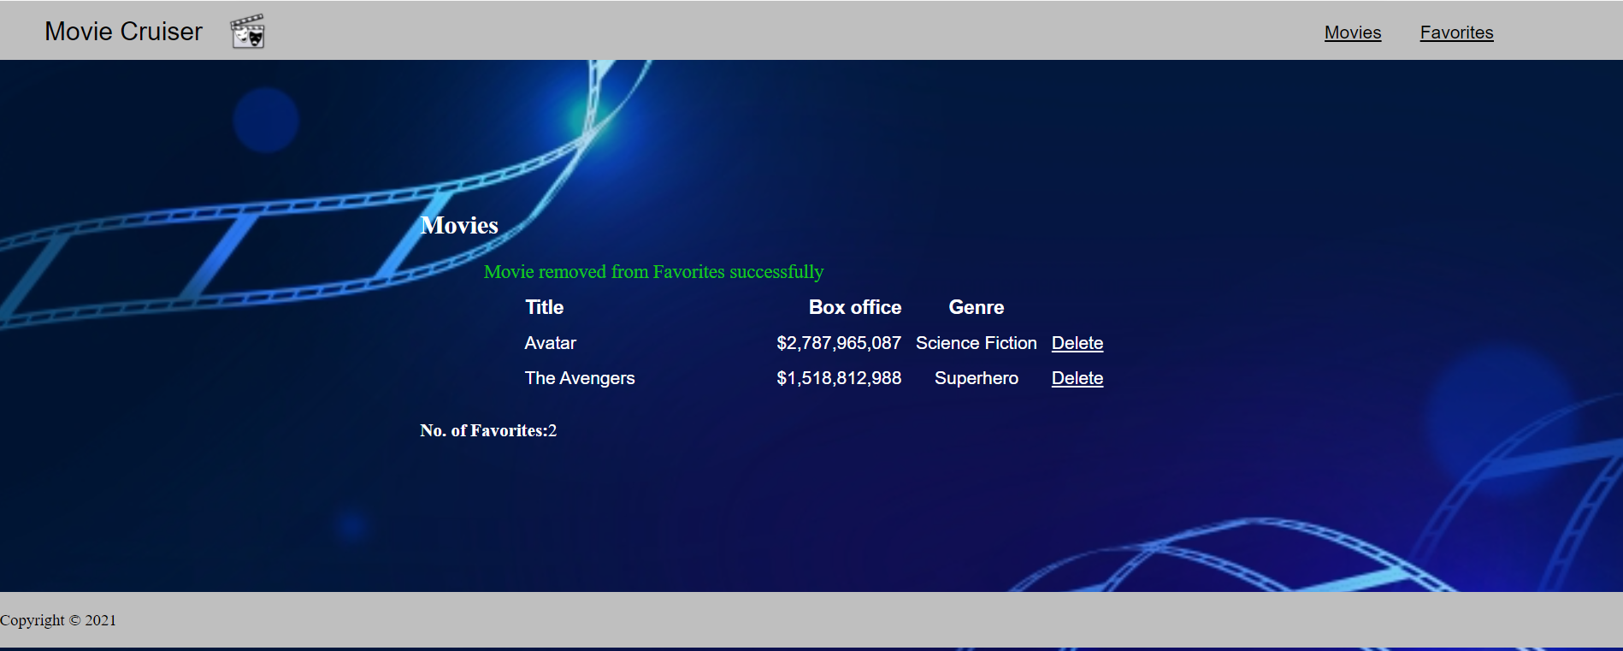

5.9 Customer Favorite Empty Message

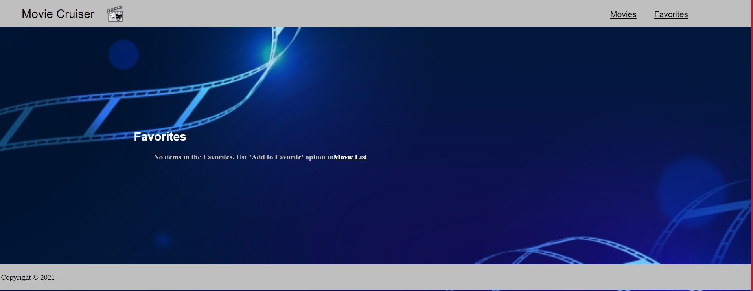

* 1. Admin Home page:

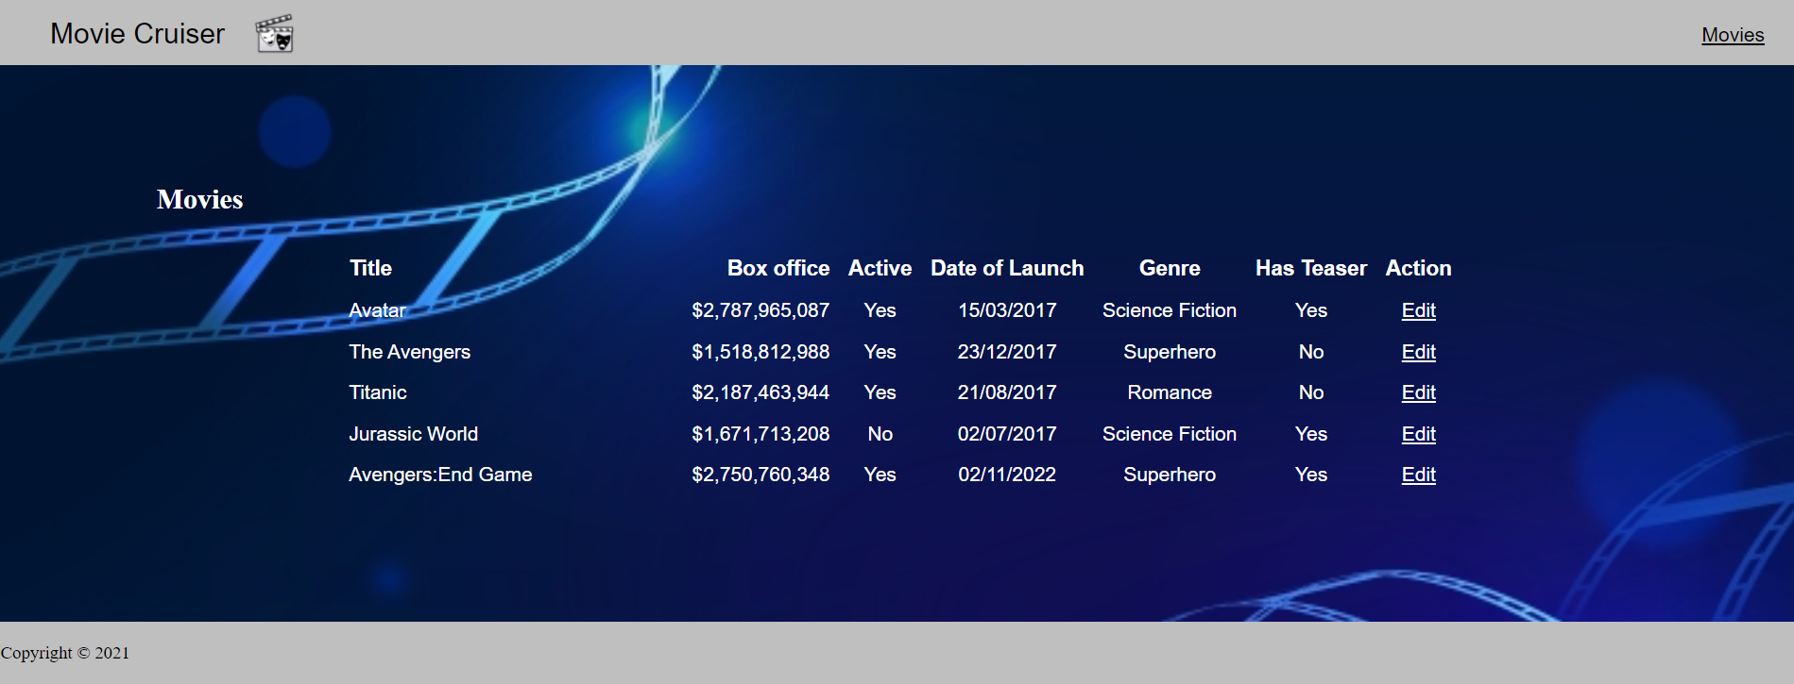

* 1. Admin – Add / Edit Item Page

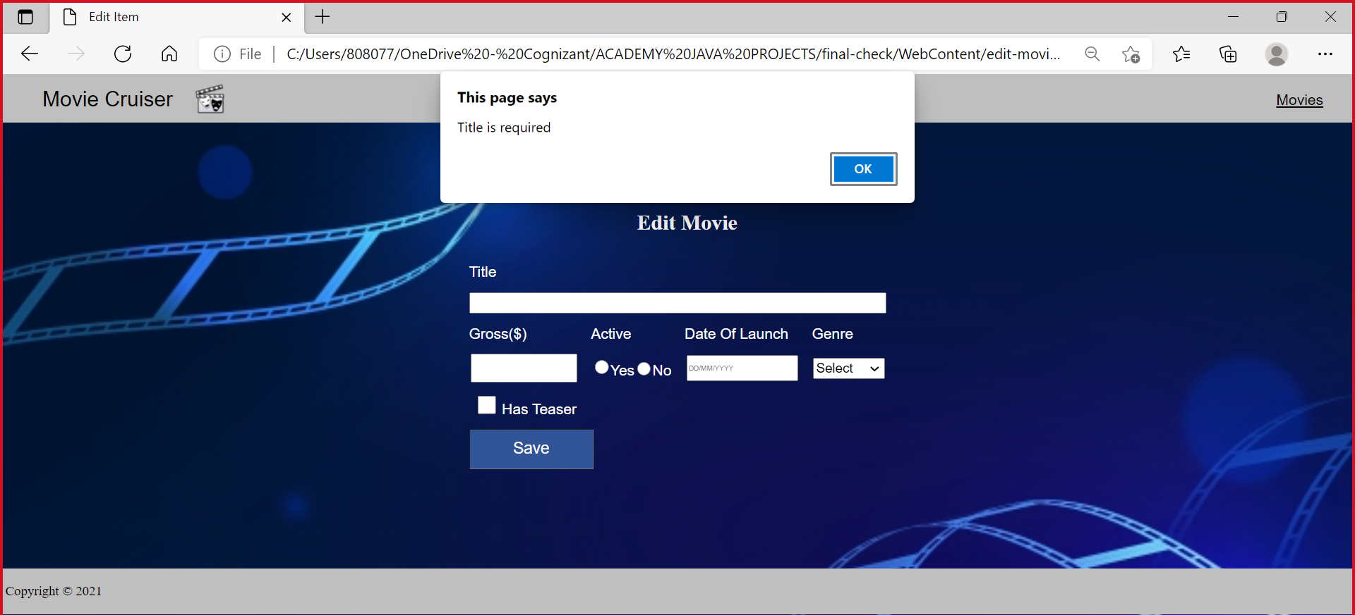

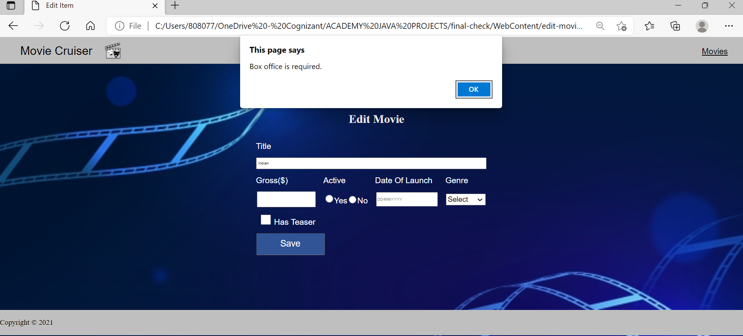

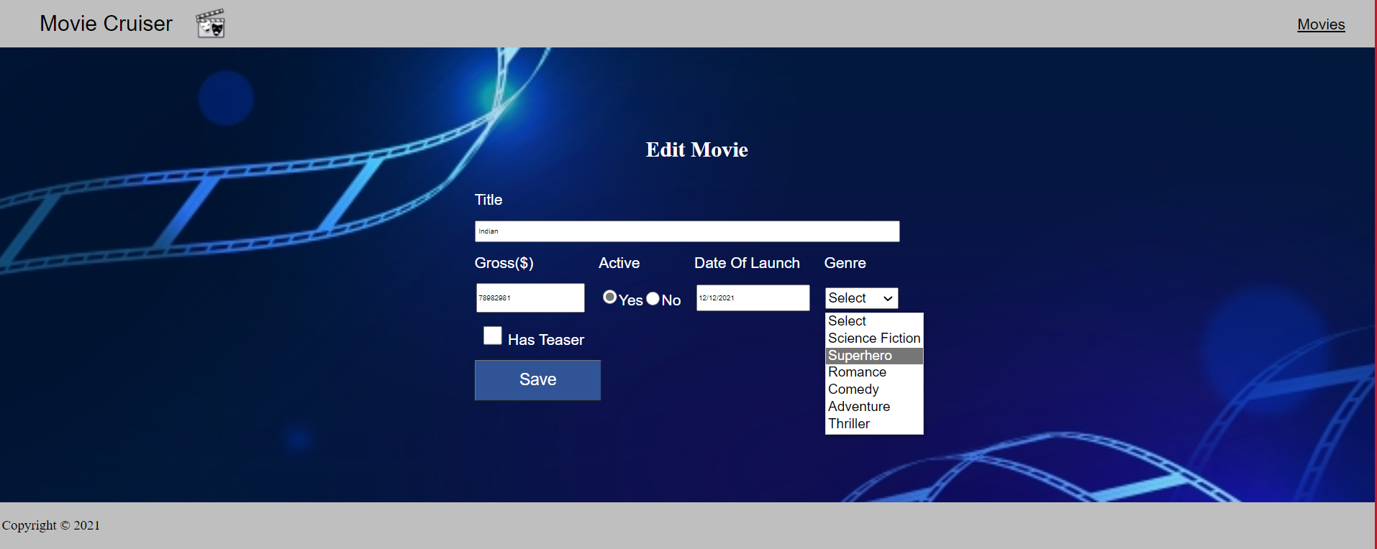

* 1. Movie added successful message:

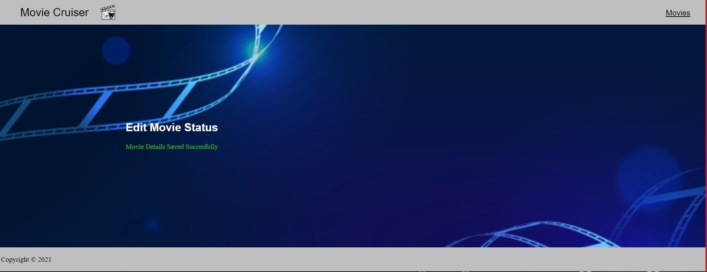

1. **CONCLUSION AND FUTURE ENHANCEMENTS**
   1. Conclusion

It is concluded that the application works well and satisfy the end users. The application is tested very well, and errors are properly debugged. The application is simultaneously accessed from more than one system. Simultaneous login from more than one place is tested.

The main aim of developing is to provide user friendly and easy way to track the Movie box office statistics anyone from anywhere the project greatly helped in understanding the various phase in website development and exposure to a new developer platform.

Future enhancements can be made to the application. So that the web application functions are very attractive and useful manner than the present one.

* 1. Future Enhancements

In the future development, we can enable the facility to let the customer/user to review & book the tickets in various ticket booking website through our platform. In the admin side, we can enhance the service by adding the query / FAQ sections to make the website even more efficient to use.